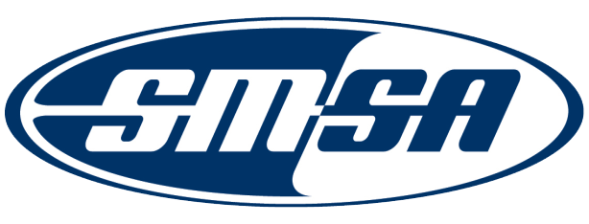
Nomination for the
2024 SMSA Outstanding Individual Member Award
The SMSA Communications and Membership Committee is seeking nominations for the 2024 SMSA Outstanding Individual Member Award. This annual Award recognizes individuals who through their dedication, commitment and contribution to motorcycle safety have made a positive impact on a national, state or local level. SMSA selects one person annually for this award. Nominees must be currently associated with the SMSA or an SMSA member’s program or organization. Individuals may not nominate themselves; individuals that have previously received this award are not eligible. However, individuals who were nominated, but did not receive an award will stay in the nomination pool for up to 3 years. Members of the Communications and Membership Committee who have been nominated must abstain from discussion and selection.

All nominations shall be submitted no later than June 28, 2024 to office@smsa.org.

Nomination Requirements

Nominations shall include:

- A description of the nominee’s relationship to the SMSA or Member’s program or organization
- A brief description of the nominee’s contributions and accomplishments in motorcycle safety and how they impacted national, state or local efforts
- The nominator’s rationale and justification for nominating this individual

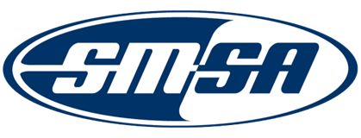

Nomination Cover Sheet Date: ___________________

Nominations will be valid for up to three (3) years for Nominees who do not receive an award.

Nominee’s Contact Information

Name of Nominee: ___________________________________________________________________________________
Address: ______________________________________________________________________________________________
City: ______________ State: ___ Zip: ______________________________
Phone: ____________________________________ Email: ________________________________________
Organization Nominee Represents: ________________________________________________________________
Position Held: ________________________________________________________________________________________
Number of years involved in motorcycle safety: __________________________________________________
Relationship to SMSA/Member’s Program/Organization: _______________________________________
_________________________________________________________________________________________________________

Nominator’s Contact Information

Nominator Name: ______________________________________________
Address: ______________________________________________________________________________________________
City: State: ______________ Zip: ____________________________
Organization Nominator Represents: ______________________________________________________________
Position Held: ________________________________________________________________________________________
Phone: _______________________________________ Email: ________________________________________
Brief Description:

Brief Rationale and Justification:

