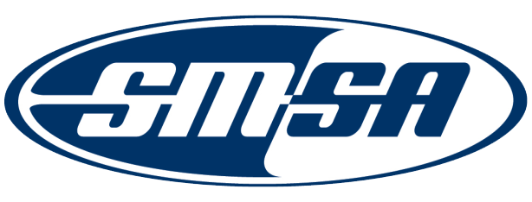
Nomination for the
2024 SMSA Outstanding State Member Award
The SMSA Award Committee is seeking nominations for the 2024 SMSA Outstanding State Member Award. This is an award that recognizes a State with a significant accomplishment that supports motorcycle safety that may serve as a promising practice for other State Programs.

Nominees must be currently associated with the SMSA and have an active membership.

All nominations shall be submitted no later than June 28, 2024 to office@smsa.org.

Nomination Requirements

Nominations shall include:

- A brief description of the state’s most recent efforts in motorcycle safety and/or education (can be a single effort or campaign).
- A brief description of how the accomplishments impacted motorcycle safety and/or education in the state.

Please complete the form on the following pages.

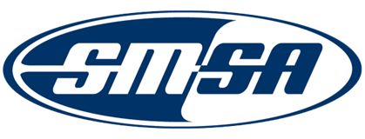

Nomination Cover Sheet Date: ___________________

Nominations will be valid for up to three (3) years for Nominees who do not receive an award.

Nominee’s Contact Information

State / State Organization: __________________________________________________________________________
Contact Person: ______________________________________________________________________________________
Address: ______________________________________________________________________________________________
City: ______________ State: ___ Zip: ______________________________
Phone: ____________________________________ Email: ________________________________________

Nominator’s Contact Information

Nominator Name: ______________________________________________
Address: ______________________________________________________________________________________________
City: State: ______________ Zip: ____________________________
Organization Nominator Represents: ______________________________________________________________
Position Held: ________________________________________________________________________________________
Phone: _______________________________________ Email: ________________________________________

Brief Description of Efforts:

Brief Description of Impact of Accomplishments for the State:

